1. Tell what machine you ran this on

Zephyrus 14

1. What do you think the actual volume is?

1, I guess.

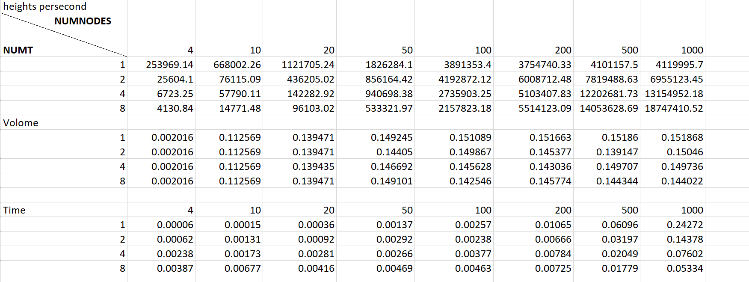

Performance as a function of NUMNODES with colored lines showing different NUMT values

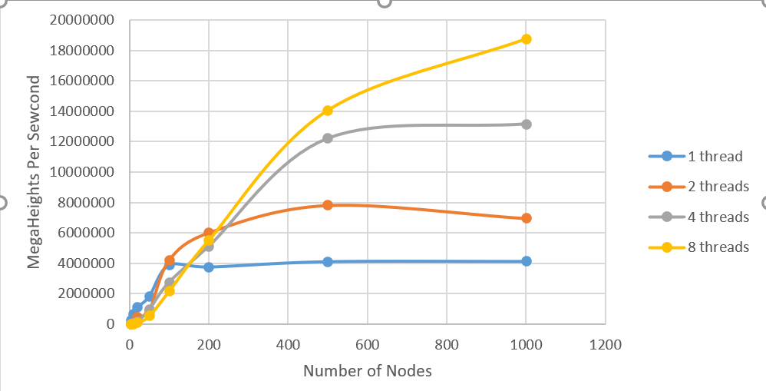

Performance as a function of NUMT with colored lines showing different NUMNODES values

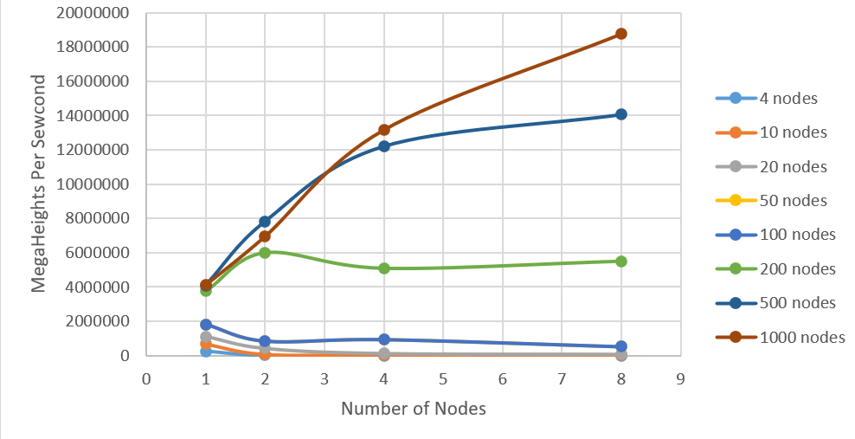

1. What patterns are you seeing in the speeds?
   1. With the threads increase, the speed increase， except for the low nodes area;
   2. With the increasing of the number of nodes we use, the speed increase.
2. Why do you think it is behaving this way?
   1. For low threads part, maybe the costing time of separating jobs cause this;
   2. Is due to each area of point (iu and iv consist of) is smaller along with the number of nodes increase.
3. What is the Parallel Fraction for this application, using the Inverse Amdahl equation?

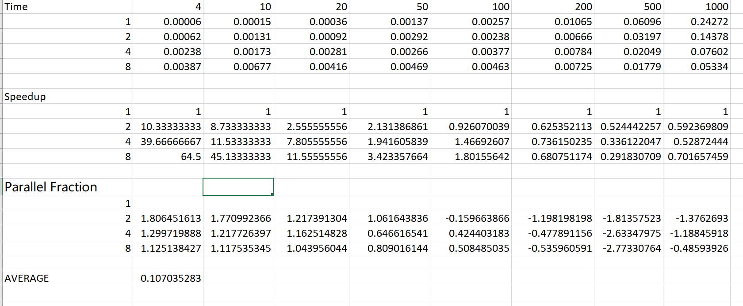 Averagely, it’s 10.7%.

1. Given that Parallel Fraction, what is the maximum speed-up you could *ever* get?

Max Speedup = 1 / (1-F_p) =1.12.